ndtset 2
getwfk -1
#occopt 4
#tsmear 0.05
kptopt 1
nshiftk 4
shiftk 0.5 0.5 0.5
0.5 0.0 0.0
0.0 0.5 0.0
0.0 0.0 0.5
ngkpt1 2 2 2
ngkpt2 4 4 4
acell 3*7.57
angdeg 90 90 90
xred
0.0000000000 0.0000000000 0.0000000000
0.5000000000 0.5000000000 0.5000000000
0.0000000000 0.5000000000 0.5000000000
0.5000000000 0.0000000000 0.5000000000
0.5000000000 0.5000000000 0.0000000000
optcell 2
ionmov 3
ntime 10
dilatmx 1.05
ecutsm 0.5
ntypat 3
znucl 56 22 8
natom 5
typat 1 2 3 3 3
ixc 1
ecut 45.0
nstep 20
toldfe 1.0d-6
diemac 12.0

This is input files
> ===outvars: echo values of variables after
> computation --------
> acell1 7.7336791838E+00 7.7336791838E+00
> 7.7336791838E+00 Bohr
> acell2 7.7310617281E+00 7.7310617281E+00
> 7.7310617281E+00 Bohr
> amu 1.37327000E+02 4.78800000E+01
> 1.59994000E+01
> diemac 1.20000000E+01
> dilatmx 1.05000000E+00
> ecut 4.50000000E+01 Hartree
> ecutsm 5.00000000E-01 Hartree
> etotal1 -7.9743862784E+01
> etotal2 -7.9744101722E+01
> getwfk -1
> ionmov 3
> jdtset 1 2
> kptrlen1 2.62232492E+01
> kptrlen2 5.24464985E+01
> kptopt 1
> kptrlatt1 2 -2 2 -2 2 2 -2 -2 2
> kptrlatt2 4 -4 4 -4 4 4 -4 -4 4

> znucl 56.00000 22.00000 8.00000

However, the determination of the optimized lattice constant of cubic BaTiO3 is below:

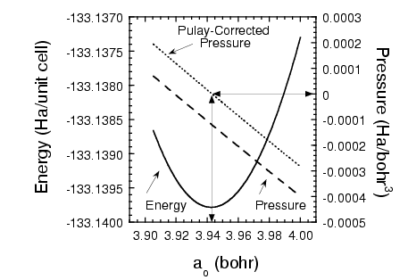
thus the difference of the optimized lattice constant of cubic and Energy is about 100%.

Can you give me some information about that.

